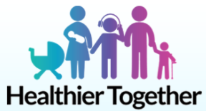
The Healthier Together programme relies upon patients and healthcare professionals working together to improve how local healthcare is delivered. The website provides advice for parents, young people and pregnant women, and clinical resources to support healthcare professionals – which means that your child is likely to receive consistently high-quality care, irrespective of which healthcare professional they see.
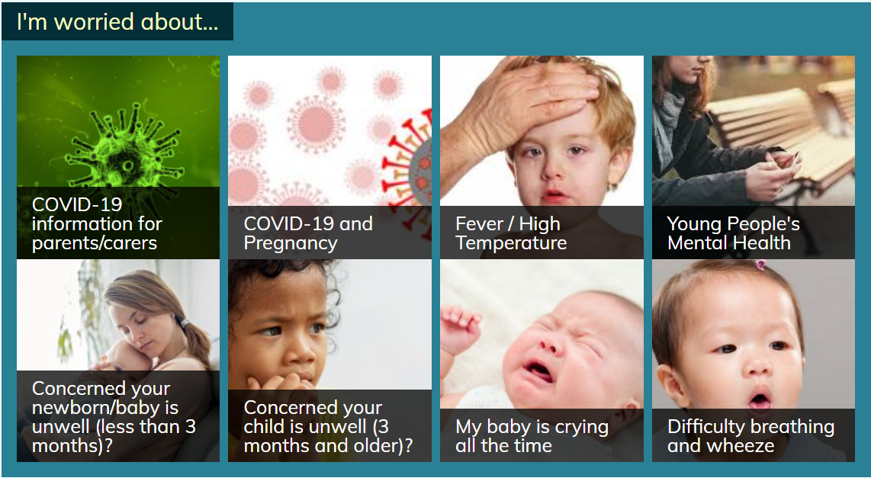
You’ll find clear information on common childhood illnesses, including advice on what ‘red-flag’ signs to look out for and how long your child’s symptoms are likely to last.

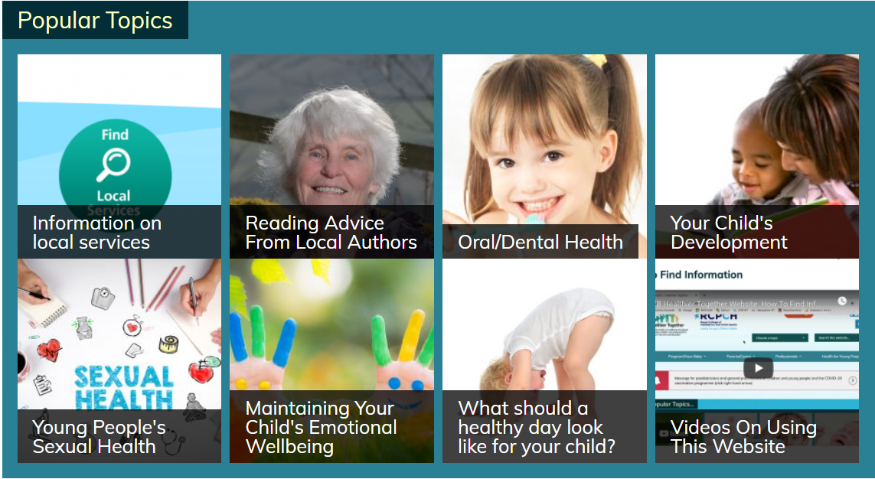
Healthier Together is a partnership project which continues to grow by putting children, young people and family’s needs at the heart of the website.
https://what0-18.nhs.uk/
SMS function to send the link to the send to a friend

